**Study identifies safer acute stroke treatment: Modified medicine dosage**

* **PTI**

 |

* Updated: May 11, 2016 17:56 IST

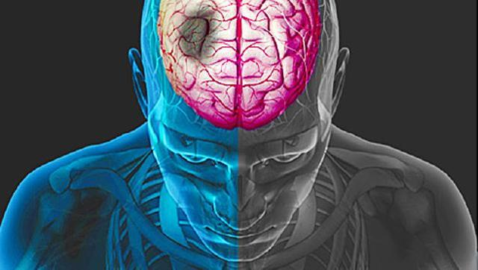

**Researchers said that the findings can change the way the most common form of stroke is treated globally, including in India where an estimated 1.2 million people suffer from ischaemic strokes. (webmd)**

Reducing the dosage of a key medication currently used to treat strokes helps reduce risk of bleeding and improve survival rates of patients, a study said on Wednesday.

Researchers said that the findings can change the way the most common form of stroke is treated globally, including in India where an estimated 1.2 million people suffer from ischaemic strokes and the high cost of the drug, lack of health infrastructure and public awareness are the reasons for underutilisation of this treatment. Professor Jeyaraj D Pandian, who was involved in the concept and design of the study, said that intravenous rtPA (or alteplase) therapy is the currently approved one within 4.5 hrs after the onset of stroke symptoms and this drug breaks and dissolves the clot in the blocked arteries inside the brain.

However, very few patients in India receive this drug because of late arrival to the hospital or unable to afford the treatment. The cost of the drug is about Rs 67,000.

Researchers said that the high cost of the drug, lack of health infrastructure and public awareness about stroke are the reasons for underutilisation of this treatment in India.

Researchers at the George Institute for Global Health investigated a modified dosage of rtPA which can be considered to be given at a subsidised rate at all government hospitals to eligible patients that can reduce serious bleeding in the brain and improve survival rates.

“It is hoped that the findings from this trial called ‘Enchanted’ involving more than 3000 patients in 100 hospitals worldwide could change the way the most common form of stroke is treated globally.

|  |
| --- |
|  |
|  |

“The study shows that if we reduce the level of dosage, most of the clot busting or dissolving benefits of the higher dose is maintained but there is significantly less bleeding inside the brain, thereby improving the survival rates. On a global scale, this approach could save the lives of tens of thousands of people,” a statement from The George Institute for Global Health said.

Stroke or brain attack is the leading cause of death and disability in rural India while an estimated 1.2 million people in India suffer ischaemic strokes which is blockage of an artery that supplies blood to the brain, each year.

Worldwide, the figures are estimated to be 2 million in China, 640,000 in the USA, 120,000 in the UK and 40,000 in Australia.

The findings of the study showed that compared to standard dose (0.9mg/kg body weight), the lower dose (0.6mg/kg) of rtPA reduced rates of serious bleeding in the brain, known as intracerebral haemorrhage (ICH) by two-thirds.

It also found that after 90 days, 8.5% of patients died after receiving low dose rtPA, compared to 10.3% who received the standard dose.